Female Genital Washing Advice
Information for Patients

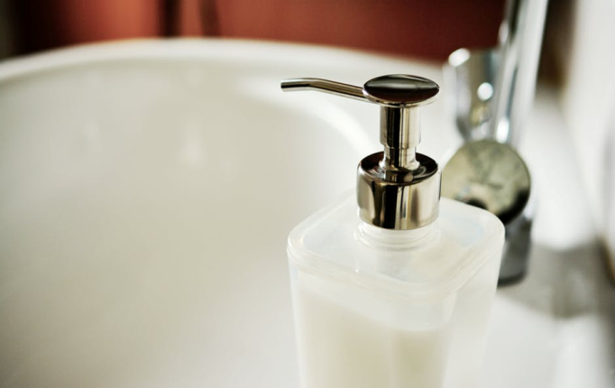
You are about to start a new drug to control your diabetes which is an SGLT2 inhibitor.
This drug works to control your diabetes by increasing the amount of sugar that is removed from your body in your urine.
It is a very effective drug but it does increase your risk of developing fungal infectionsof the genital skin. If this happens you may notice itching, redness and tears in the genital skin which make it uncomfortable to sit down, to pass urine or have your bowels open. It can also make having sex extremely painful. You are also more likely to get urinary tract infections. If this happens then symptoms include stinging or burning when passing urine and the need to pass urine more frequently.
If you were to develop very severe pain in the genital area accompanied by swelling, redness, a temperature and you felt unwell then you should seek urgent medical attention.
If symptoms do develop it is important to treat them quickly to stop them getting worse.
These potential side effects can be reduced by following the tips below.

Follow the advice below – and use hydromolointment to both wash and to protect the genital skin.
If you think you have developed any of the symptoms above ask your pharmacist for an antifungal cream-Clotrimazole cream- to use on the skin. You could also take a Fluconazole tablet from pharmacy if this does not interact with any of your other medication. Take a second tablet after 3 days and a third tablet after another 3 days. (You will have to ask your GP to prescribe the second and third tablet). If your symptoms do not start to improve in a few days speak to your GP/Diabetic team/call Chalmers? for more advice.
If you have urinary symptoms ask your pharmacist to test your urine. If you require an antibiotic following this test they can provide this for you without you having to go to your GP. They will let your GP know you have received treatment. (Pharmacy First- allows pharmacist in Scotland to dispense all of the medication mentioned above: Hydromol Ointment, Fluconazole and Clotrimazole cream, without charge if you have a GP in Scotland).
Tip 1: Avoid Soap.
Soap was first invented more than 2000 years ago. Soap makes us clean by removing the oils we produce to lubricate the skin from our bodies, as well as the skin bacteria that iscontained in the oils.
Soap is no longer the best option to clean with. Soap can cause the skin to dry out too much resulting in cracking of the top layers of your skin, called superficial layers.
Micro-organisms that live on the skin can get into these cracks and this can result in itching and soreness. This particularly affects the genital skin.
Using any soap product above the waist can mean that the product will wash onto the genital skin when you rinse in the bath or shower.
Washing with just water can also dry out the genital skin. It would be best to use a soap substitute over the entire body instead.
Tip 2: Use a Soap Substitute
A more modern way to wash is to use a soap substitute. Soap substitutes remove the bacteria that make us smell but add moisture to the skin, instead of taking it away. If your skin is well moisturised, this will help to stop it from getting itchy and sore.
Soap substitutes are widely available in all pharmacies. Depending on the brand required you can get them off the shelf or from the pharmacy team without a prescription. Ask the pharmacy for advice if you are not sure. At Chalmers we recommend Hydromol Ointment. You can use this to wash your entire body and then to moisturise or protect any irritated areas of skin after you have dried your body.
Tip 3: When washing hair
It is important not to let shampoo or conditioner run onto the genital skin.
This means you should not wash your hair in the bath and when in the shower keep your head forward when rinsing products from your scalp.
Tip 4: Avoid bubble baths, essential oils or soap/shower gels in the bath
They will get onto the genital skin and may cause irritation. You can buy non-soap bath additives such as Aveeno Bath oil instead.
Tip 5: Avoid wet wipes
Do not use wet wipeson the genital skin-they are designed for babies who have much ‘tougher’ genital skin than adults.
Tip 6: Avoid feminine hygiene products
Do not use feminine washing products – even if they say they are pH balanced. They are highlydisruptive to healthy bacteria in the vagina.
Tip 7: Avoid Douching
Do not ‘douche’- this meanswashing out the vagina with water or other products. This damages the healthy vaginal organisms and alters their natural balance in the vagina.
Tip 8: Avoid Fabric Softeners
Do not use a fabric softener or a 2 in 1 washing product when washing your clothes.
The perfume in these products gets onto the genital skin and causes drying and damage to the skin.
Tip 9: Do not shave the genital skin.
Shaving the skin will damage the top layers of skin and increase your chances of getting an infection. Shaving gels also contain irritant chemicals and should be avoided. ‘Trimming’ the hair may be a better option long term. Though when the skin is very uncomfortable you should not remove hair at all.
Need More Information?
If you need to contact the Chalmers Centre, our details are:
Chalmers Centre for Sexual Health
2a Chalmers Street
Edinburgh
EH39ES
Tel: 01315361070

